Day #8 – Do I need any licenses to get a contract?

Hello, again!

Hope yesterday’s lesson made you see everyone’s around you strengths and how this can be valuable to you. Teamwork makes dreamwork!

Today I will answer the one question I get asked time after time. Eric, do I need a special license to do this?

Want to hear the good news? If so, click below to find out.

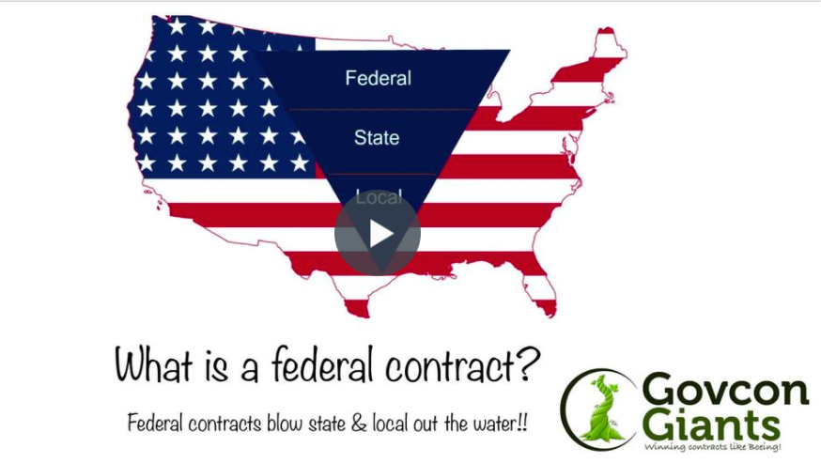

For today’s assignment, I just want you to take a few minutes to read to see if you have what it takes to make this happen.

Read on to see if you have what it takes.

Big hug,

Eric Coffie

